Budget amendment

Amendment to Motion 1 – Council Business Plan and Budget 2013+

After “That the Council Business Plan and Budget 2013+, including the revenue budget for the financial year commencing 1April 2013 of £1,035.488m, be approved” insert “following its amendment as detailed below and in Motion 2”:-

Delete all in part one foreword and replace with:-

“Foreword by Leader of the Opposition, Councillor Mike Whitby

‘Services free at the point of delivery’

The Coalition Government has listened and delegated in an unprecedented manner power and decision making and direct funding to the city.

The City Council must now seize the opportunity to enhance its role through the Enterprise Zone, City Deal, GBSLEP and the ‘Greater Birmingham Project’ in delivering the economic framework for prosperity, jobs and skills that underpins a truly global city that compliments the national growth agenda. The new freedoms and potential funding streams on offer to Birmingham aligned to our financial settlement and grants more accurately conveys the financial generosity of the Coalition Government towards the city and Birmingham City Council.

The heart of our amendment restores services to vulnerable people, gives choice to parents, protects community facilities, restores funding to provide free at the point of delivery a range of services that enrich our environment and contribute to a cleaner and greener Birmingham. Our amendment will also enable all Councillors through a generous community chest to capture the aspirations of their local communities and creates a dialogue with powerful partners to support the most vulnerable in our society.”

In part one introduction remove section “Local and Nation Context” on pages 15, 16 and 17.

Replace with:-

“Headline facts and figures of this City Council Budget

- Overall this City Council will receive only £1.78 Million less grant funding from the Government in 2013/2014 than it did in 2012/2013, see page 188 Council Business Plan and Budget 2013+. In addition we understand that further grants for 2013/14 are still to added and in the end it is likely the Council will receive more grant funding next year than last.

- In the coming year this City Council will spend £50.571 Million more than it did in 2012/2013, see page 223 Council Business Plan and Budget 2013+

- This means the Net Expenditure of the Council will reduce by £23.07 Million in 2013/2014 out of a £3.4 Billion Budget, see page 225 Council Business Plan and Budget 2013+

- Out of the 8 Core Cities only one Council (Nottingham) has had a smaller reduction in spending power than Birmingham. Indeed looking across the Metropolitan Councils only 2 out of 36 (Sandwell and Salford) have smaller reductions than Birmingham.

- Furthermore Birmingham (-0.9%) has done better than England wide (-1.7%), London (-1.1%), and Shire area (-1.8%) averages as well in the coming year.

- This reduction is equivalent to £23.91 per dwelling in Birmingham next year.

- Given this the Council does not feel it would be right to shift from a ‘services free at the point of delivery’ to a top up tax on certain services used model, in Birmingham.

- This Council strongly believes that Youth Unemployment must be tackled; however cutting Community Chest grants is not the way to do this. Therefore, while still supporting the youth unemployment and apprentice scheme, this Council would not cut Community Chest funding.

- This Council does not believe that recycling is increased by limiting the amount of recycling that can be thrown away, nor by charging for recycling or waste to be collected. Therefore this Council will cancel the proposed ‘Garden Tax’, will restore Special Street Collections and will keep 3 free Bulky Waste collections of up to 6 items each time.

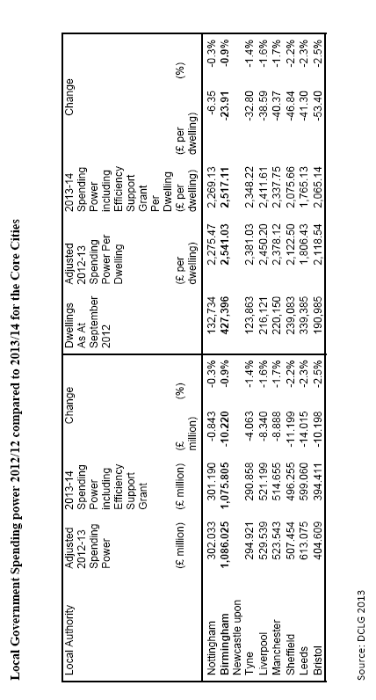
- Finally this Council feels that more must be done to support Vulnerable and/or Children living in poverty. Therefore we are protecting the Children Centres Budget and will work with the Birmingham Schools Forum to develop a one off Schools Forum fund to help vulnerable and/or children living in poverty.

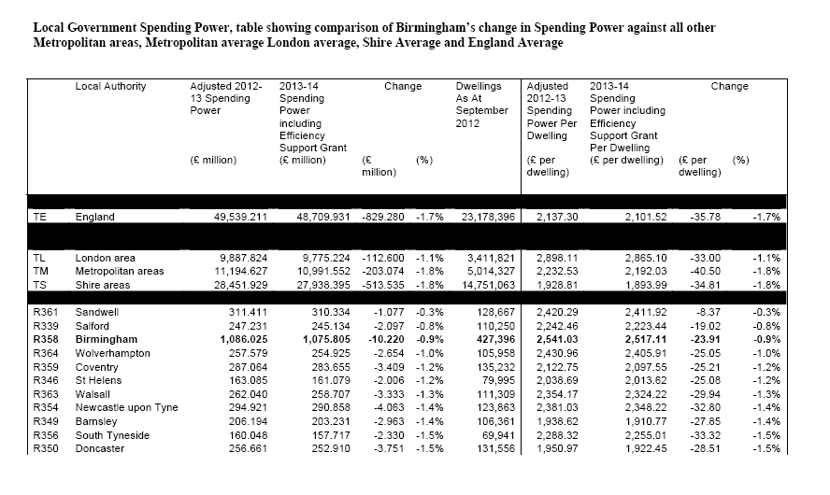
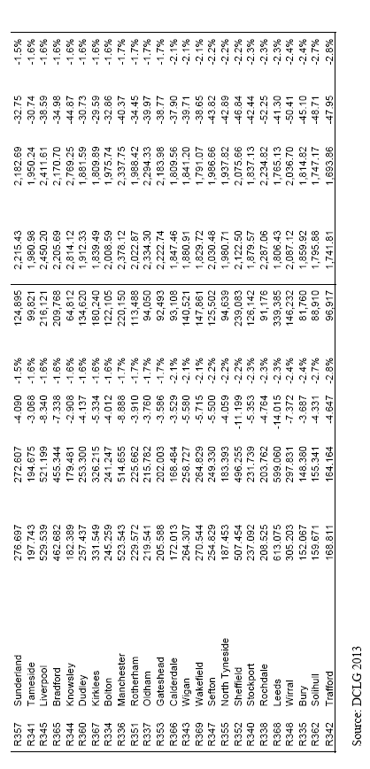

The Audit Commission Context

The Audit Commission Report, ‘Tough times 2012’ published November 2012, states on page 17, Deprived areas…still receive substantially higher levels of government financial support, per resident, than more affluent areas.
It should be noted that the level of Government support to the West Midlands per capita after the changes between 2010-13 is more than 50% higher than what the East Midlands, East of England, South West and South East will receive.

How the Council Budget varies compared to inflation since 2004

When comparing the City Council budget each year since 2004 compared to what a constant budget increased only by inflation you can see that the Council Budget still stands at a higher level in 2013/14. Indeed the City Council is £160.8462 Million better off than an inflation increased budget since 2004 would have produced. Clearly if you thought the Council received sufficient funding in 2004, taking into account inflation it is receiving even more this year.

The ‘Jaws of Truth’

In part two “Policy Priorities” add at end of page 20

“This Council’s Policy Priorities will include:-

- Helping Vulnerable Children and/or children living in poverty
- Will protect and grow community led youth activities
- Will protect Community Chest, so that devolution means providing local communities budgets and real power, not centralisation by the back door
- Will protect Childrens Centres
- Will keep weekly refuse collections and fortnightly recycling services that are free at the point of delivery
- Invest to increase adoption rates
- Will protect and/or increase current levels of Grit Bins and will not reduce them
- We will maintain both the current Bulky Waste and Special Street collections provision
- We will not charge for the use of Car Parks in residents of Birmingham’s Parks

In part three “Feedback and Analysis from Consultation” page 24
Add to the bullet points after line 23:-

- “this Council did not consult on changes to Community Chest and so it would not be acceptable to reduce it in this budget.
- Likewise this Council did not consult with residents on charging for the collection of Green Waste and so this would be unacceptable. Particularly when 3 out of 4 Councils do not charge”

In Appendix 1A, page 135, under the headline “Embracing our new public health role and promoting well being through the work of the (Shadow) Health & Well Being Board”. Add a fourth bullet point:-

- “This Council recognises that the role of Walk In Centres and Urgent Care Centres in Birmingham are vital to the health and well being of residents. Therefore the Council will use its position on the Health and Well Being Board, working with the local commissioning groups, to support and protect them in the years ahead.”

In Appendix 4, page 178, under the headline “Fleet and Waste Management”

Delete points 3.2 and 3.3 and replace with:-

“3.2 This Council feels that it is a key role of the City Council to provide a Clean, Green and Safe City. To do this street cleansing levels must be maintained, not cut. While Bulky Waste Collections and Special Street Collections ensure that fly tipping is kept off our streets. This Council is concerned that changes to these services would lead to an increase in the amount of waste on our streets and sent to landfill.

3.3 This Council would, while accepting in full the DCLG grant for £29.8 Million renegotiate the terms to allow the retention of the current waste and recycling system with added efficiencies and the development of a food waste collection system. Both the proposed extension to the recycling reward scheme and the increased frequency of dry recyclables to those wards with the greatest propensity aspects, within the grant, would be retained. This would allow the Council to drastically increase recycling rates while allowing people to recycle as much as they wish through the City waste collection network.”

Amendment to Motion 2 – Revenue Budget

After “that the budget allocations to various Directorates of the Council, as set out in Appendix 5G-I to the Business Plan”, delete “be approved” and insert:

“be amended and approved to reflect the following changes in budget
Allocations”

In section “New Savings Proposals and Revisions to Previous Plans” pages196 - 222 Appendix 5F add:-

“This Council considers the following savings proposals unacceptable and therefore removes them from the proposed budget:-

Restored budget proposal | 2013/14  £m | 2014/15  £m | 2015/16  £m | 2016/17  £m | Reason for restoring
Adults and Communities Directorate
9.  Full year effect of Meal subsidy reduction | 0.400 | 0.400 | 0.400 | 0.400 | This Council appreciates that some of the most vulnerable elderly people rely upon this service to help maintain independent living. We therefore reinstate this grant.
13. Supporting People | 1.992 | 1.492 | 1.492 | 1.492 | This Council does not feel it would be appropriate to reduce the Supporting People grant any further at this time
Children, Young People and Families Directorate
4.  Home to School Transport | 1.000 | 1.000 | 1.000 | 1.000 | This Council believes parental choice is key in education. Parents have a right to choose the school they feel is correct and we have an obligation to support the child’s transport to and from school.
6.  Adoption | 0.100 | 0.100 | 0.100 | 0.100 | We feel that adoption is a vital service. Therefore any saving made in service redesign would be reinvested within the service.
12.  Youth Offending Service | 0.400 | 0.400 | 0.400 | 0.400 | This Council wishes to ensure that preventive work to stop reoffending continues and so we restore this saving.
16.  Connexions | 0.750 | 1.250 | 1.250 | 1.250 | This Council does not believe further savings can be made from Connexions at this time. Therefore we restore this saving, to allow further income generation work to be developed.
26.  Childrens Centres | 1.000 | 1.000 | 1.000 | 1.000 | Children have a right to access a children centre whether they live in Lozells, Sutton Coldfield, Erdington or Northfield and so we will restore this saving to protect all the City Council’s Children Centres
Development and Culture Directorate
1.  Forward 4 Work Service – Disposal of Lease of the Inkerman Street Building | 0.060 | 0.060 | 0.060 | 0.060 | To protect training opportunities for some of the most vulnerable people in Birmingham we will cancel this disposal.
Local Services Directorate
1a.  Bulky Waste Charges (First collection free up to 6 items and second & subsequent collections charged at £25.00) | 0.200 | 0.200 | 0.200 | 0.200 | We will restore the current 3 free bulky waste collections of up to 6 items each collection. This will help keep fly tipping down.
1c.  Cease subsidy for special street collections | 0.400 | 0.400 | 0.400 | 0.400 | We will restore and protect all Special Street collections from being cancelled by restoring this proposed saving to the budget. This will help ensure fly tipping is kept down. Saving the Council money in the long term.
1e.  Cease the provision of black and green sacks | 1.000 | 1.000 | 1.000 | 1.000 | The Council will now continue to provide bags for residents waste, promoting a clean and safe city.
1g.  Introduce a chargeable green waste service (£35.00 annual charge) | 0.400 | 2.500 | 2.500 | 2.500 | Residents pay Council tax for the City to provide Services. Therefore this Council believes basic services like waste collection must remain free at the point of delivery. Therefore we will cancel any proposed charges for collection of garden waste.
2. FWM – Review current street cleansing levels – City Centre | 0.220 | 0.220 | 0.220 | 0.220 | To reduce street cleaning would make our city less attractive to visitors and investors alike. It therefore would cost the Council lost revenue in the long term. We therefore will protect current cleansing levels.
3. FWM –  Reduce street cleansing – mechanical sweeping | 0.320 | 0.320 | 0.320 | 0.320 | To reduce street cleaning would make our city less attractive to visitors and investors alike. It therefore would cost the Council lost revenue in the long term. We therefore will protect current cleansing levels.
4.Parks and Highways – Nursery and Floral Services | 0.383 | 0.491 | 0.491 | 0.491 | This Council does not agree with charging for the use of Park, Car Parks. No one should be prevented from using our Parks due to cost.
5. Highways Horticultural and Floral Decorations | 0.225 | 0.225 | 0.280 | 0.335 | To reduce floral displays would make our city less attractive to visitors and investors alike. It therefore would cost the Council lost revenue in the long term. We therefore will protect current floral display levels. Helping to promote a Clean, Green and Safe City for everyone.
6. Highways – review and optimise current maintenance levels | 1.250 | - | - | - | Due to the bad weather this year, we would re-invest this saving into a special fund to fill more potholes across the city.
7. Car parking service review | 0.100 | 0.100 | 0.100 | 0.100 | This Council will not introduce charging for on street parking in Suburban town centres and so this proposal has been scrapped
10. Building Support Services – porters, curators and security – reduced provision | 0.200 | 0.200 | 0.200 | 0.200 | The Porters, Curators and Security staff enable the full operation of the Council House and external facilities and without them the Public access to such buildings would be hampered. Therefore this saving has been removed.
14. New Support Service Structure for District Quadrants | 0.389 | 0.389 | 0.389 | 0.389 | Any proposed savings found here would be retained by the District Budgets for discretional use to preserve the current level of district funding.
15. Your City Your Birmingham | 0.438 | 0.438 | 0.438 | 0.438 | This budget would remain with Districts to ensure that Birmingham remains a Clean, Green and Safe City to live, work and play in.
16. Youth Service | 0.470 | 0.470 | 0.470 | 0.470 | Any savings that can be made by service redesign will remain for front line service delivery by with the Youth Service.
Total restored spending commitments | 11.697 | 12.655 | 12.71 | 12.765
“

Add to Appendix 5F the following new savings:-

“Appendix 5Fcontinuation new saving proposals

Saving proposal | 2013/14  £m | 2014/15  £m | 2015/16  £m | 2016/17  £m | Description
Increased for non school services | 0.500 | 0.500 | 0.750 | 0.750 | The Council would look to increase trade with other public sector bodies.
Schools Forum Contribution to vulnerable children | 4.000 | - | - | - | One off commitment to fund new ‘Birmingham Schools Forum support fund’ to help vulnerable children and children living in poverty within the City of Birmingham. The amount secured would directly relate to how much was available in the pot to spend.
Savings on procurement processes | 1.500 | 2.500 | 4.500 | 6.500 | Given the current economic climate savings will be driven through the procurement process to deliver efficiencies for the City. Both through an open book process and asking services to be provided at a lower rate.
Reduced sickness absences from 11.8% to 10.00% | 3.000 | 6.000 | 6.000 | 6.000 | This reduction would still leave Birmingham well outside the top performing public and private sector bodies and so is an achievable first step to tackling absenteeism. First year this is deemed only a half year saving due to time to implement new policies to secure reduction.
Treasury management | No saving is listed but, the process would be closely monitored and in previous years there has been end of year savings above and beyond start year budgets through this process.
Full implementation of working with Trade Unions Scrutiny report  2011/2012, with associated reductions | 0.500 | 0.500 | 0.500 | 0.500 | This scrutiny report has already been agreed by the City Council and now would be implemented
Reduced use of agency staff by 5% | 1.000 | 1.000 | 1.500 | 1.500 | The Council will reduce excess use of Agency staff
Reduced use of consultants | 4.000 | 4.000 | 5.000 | 5.000 | The Council will reduce excess use of Consultants.
50% reduction in Equalities & European Officers | 1.000 | 1.000 | 1.000 | 1.000 | Birmingham City Council currently has more Equalities and European Officers than the rest of the Core Cities combined. A 50% reduction will bring this into line with other authorities.
Reduce outside subscriptions by the City Council | 0.500 | 0.500 | 0.500 | 0.500 | This Council does not believe all the current subscriptions are required and cannot be maintained while proposing to cut services like youth provisions. Therefore instead we will reduce subscriptions.
Pull Forward of delayed service reviews | 8.800 | 8.800 | 8.800 | 8.800 | This Council will bring forward service reviews to the value proposed in the Council budget consultation.
Review of Service Birmingham contract | Over the coming twelve months we would work with Capita to drive down costs and release savings, for the 2014/15 year onwards.
Reduction in City Council building assets | To be determined following the review of Council assets |  |  |  | The Council will carry out a review of shops, offices, factories and pubs the Council owns and sell ones which are no longer required for Council business and/or make a loss. This will be part of an on-going process.
Total new savings | 24.800 | 24.800 | 28.550 | 30.550
“

Insert new Appendix 5L:-

“Appendix 5L – new spending commitments and collated changes

Spending commitment | 2013/14  £m | 2014/15  £m | 2015/16  £m | 2016/17  £m | Reason for commitment
Restoring Community Chest budget to £125,000 per ward | 3.000 | 3.000 | 3.000 | 3.000 | This Council believes in devolution of services and therefore will restore the previous Community Chest Revenue and Capital budget of £125,000 to its full amount as one combined revenue stream. This Council believes devolution is more than words it is the devolution of Budgets not just reports.
One off fund to support vulnerable children and/or children living in poverty within Birmingham | 4.000 | - | - | - | Will fund a new Birmingham Schools Forum support Fund to support vulnerable children and/or children living in poverty within the City of Birmingham. The amount available in the pot to spend would directly relate to how much was secured.
Provision to every household of two ‘Keep Birmingham clean’ dustbins for storage of black bag rubbish | - Self funding within the Eric Pickles grant | - | - | - | The cost of this will be met by transferring the planned procurement of Wheelie Bins fund to provision of black bins to prevent black bag spillage. FWM future operating model will be modified to enforce current collection contract provision of collecting waste from doorsteps and residents’ bins.
Supporting independent resident advice service through the CAB | 0.250 | 0.250 | 0.250 | 0.250 | This Council feels it is vital that residents have access to an independent advice service. In addition this Council has been informed that the CAB require in the order of £120,000 in future years to operate. We will therefore support the continuation and future development of CAB provision in Birmingham with a grant.
Supporting the Youth Service in Birmingham | 2.000 | 5.000 | 6.000 | 8.000 | To produce a “Birmingham Youth Future” funding pot that Council and third sector Youth service providers can bid into to provide one off grants for events and programs. Bids will be submitted and monitored through the existing Ward Committee Structure.
Investment to increase Adoption rates | 1.000 | 1.000 | 1.000 | 1.000 | This Council knows that an adopted Child is given a better chance of a successful future. Therefore we will invest to increase adoptions and save the Council money in the long term.
Shelforce | 2.000 | - | - | - | This Council will invest a one off sum next year expand the product base and market new products to increase the viability of Shelforce going forward. For example plastic bins. This grant would be ring fenced for product development
Emergency Pothole fund | Self funding from saving in 6. Highways – review and optimise current maintenance levels | - | - | - | One off budget funded by equal savings to AMEY contract
Grit Bin retention | 0.250 | 0.250 | 0.250 | 0.250 | This Council views road and pedestrian safety as vital and so we will protect the current level of Grit Bin retention.
Fixed assets maintenance pot | 0.500 | 0.500 | 1.500 | 1.500 | Maintenance of Council assets are often seen as a easy saving however long term it has a significant impact on areas and budgets. This pot would be focused on Park and High Street assets in Districts
Contributions to City Council reserves | 0.103 | 2.145 | 3.840 | 3.785
Total new spending commitments | 13.103 | 12.145 | 15.840 | 17.785

Collated total changes to Council Budget:

 | 2013/14  £m | 2014/15  £m | 2015/16  £m | 2016/17  £m
Total New Spending commitments | 13.103 | 12.145 | 15.840 | 17.785
Total restored spending commitments | 11.697 | 12.655 | 12.71 | 12.765
Total savings required | 24.800 | 24.800 | 28.550 | 30.550
Total new savings | 24.800 | 24.800 | 28.550 | 30.550
Net Balance | 0 | 0 | 0 | 0

And that the Strategic Director of Corporate Resources be given the authority to reflect these changes within the appropriate appendices within the Council Business Plan and Budget 2012+”

Proposed …………………………….. Cllr Mike Whitby

Seconded ……………………………. Cllr Robert Alden

